**MST 1102- Introduction to Statistics WkSheet 1**

**(Last Name, First Name): ______________________________________________________________**

**Definition, Scope, Characteristics, Data, Variable, Measurement Scales,**

1. Is Statistics a singular word or plural word? Explain. **[3 marks]**

________________________________________________________________________________________________________________________________________________________________________________________________________________________________________________________________________________________________________________________________________________________________________________________________________________________________________________________________________________________________________________________________________________________________________________________________________________________________________________________________________________________________________________________________________________________________________________________________________________________________________________________________________________________________________________________________________________________________________________________________________________________________________________________________________________________________________________________

1. State three applications of Statistics. **[3 marks]**
2. ______________________________________________________________________________________________________________________________
3. ______________________________________________________________________________________________________________________________
4. ______________________________________________________________________________________________________________________________
5. In a recent poll respondents were asked for their political affiliation, and the responses were coded as follows: $0 \left(for PNC\right), 1 \left(forPPP\right), 2 \left(for AFC\right), 3 (for WPA)$. If we calculate the average (mean) of the numbers and get $0.95$, can this value be interpreted? Why or why not? **[2 marks]**

**____________________________________________________________________________________________________________________________________________________________________________________________________________________________________________________________________________________________________________________________________________________________________________________________________________________________________________________________________________________________________________________________________________________________**

1. Identify whether the statement describes descriptive statistics or inferential statistics: **[3 marks]**
2. The chances of winning the Lottery are one in twenty-two million. ________________________________________________
3. From past figures, it is predicted that 39% of the registered voters in Guyana will vote for Volda Lawrence.

________________________________________________.

1. The average age of the students in the statistics class is 21 years. ______________________________________________
2. Complete the table below: **[4 marks]**

|  |  |
| --- | --- |
| **Scale of Measurement** | **Description** |
|  | There is a natural zero starting point and ratios are meaningful. |
|  | Categories are ordered, but differences cannot be found or are meaningless. |
|  | Categories only. Data cannot be arranged in an ordering scheme. |
|  | Differences are meaningful but there is no natural zero starting point and ratios are meaningless. |

1. 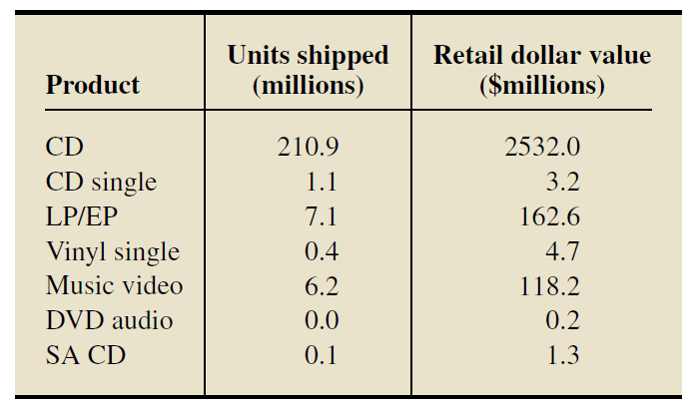Recording Industry Statistics. The Recording Industry Association of America (RIAA) reports annual statistics on shipments and revenues. For the year 2012, RIAA reported the following data on physical shipments. [SOURCE: Year-End Industry Shipment and

Revenue Statistics. Published by RIAA,c 2012.]. Identify the type of data in each column of the table. (qualitative, quantitative discrete, quantitative continuous)**[3 marks]**

Column 1: ____________________________________________________

Column 2: ____________________________________________________

Column 3: ____________________________________________________

1. 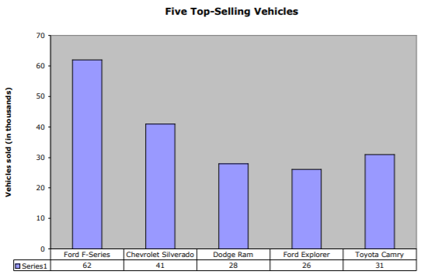Identify the scale of measurement. **[5 marks]**
2. Numbers on the shirts of the players of the Guyana Amazon Warriors. ____________________________________________
3. The data represented in the second row of the horizontal axis of the graph shown on the right. ___________________________
4. The final grades (A, B, C, D, F) on the MST 1102 Final Exam. ___________________________
5. Birth Years:_________________________________
6. The time it takes to complete a race. ______________________________________________
7. As it relates to statistics, what are the two defining characteristics of a variable? **[2 marks]**
8. ______________________________________________________________________________________________________________________________
9. ______________________________________________________________________________________________________________________________
10. The five characteristics of data can be summarized by the mnemonic CVDOT. What characteristic of data do each of these letter represent? **[5 marks]**

C: ____________________________

V: ____________________________

D: ____________________________

O: ____________________________

T: ____________________________



1. The type of smartphone owned by 5 persons was recorded as A, A, I, A, I. Identify: **[3 marks]**
2. The variable: ___________________________________________________________
3. An observation: ________________________________________________________
4. The data set: ____________________________________________________________

**A= Android, I= IPhone Total: 33 marks**